**BUILD MOBILE APP**

CONFIGURE THE MOBILE APP FOR

CONTROLLING MOTOR USING BUTTONS

|  |  |
| --- | --- |
| Date | 10 November 2022 |
| Team ID | PNT2022TMID50829 |
| Project Name | Real – time River Water Quality Monitoring and Control System |
| Maximum Marks | 4 Marks |

This time, we’ll be covering DC motor speed control via an Android application (app). For this project, the app is installed in a smartphone device that uses Bluetooth to send commands to the circuit, which controls the DC motor speed. This Android app has an eye-catching graphical user interface (GUI) that’s inviting and easy to use. We’ll use buttons, a slider, and a speedometer, making this project quite different from the others we’ve covered.

This circuit is built using only three components: Arduino NANO, the Bluetooth module HC05, and a Darlington transistor TIP122.

* The HC05 has four interfacing pins: Vcc, GND, Tx, and Rx. Here, the Vcc pin is given a 5-V supply from the Arduino board and the GND pin is connected with the board’s ground. The Tx and Rx pins are connected with Arduino’s pins D4 and D5, respectively.
* The PWM output pin D3 drives the 12-V DC motor using the TIP122. It’s connected to TIP122’s base terminal through the current limiting 330-ohm resistor.
* The TIP122 is used to amplify the current, providing the required current to the motor. The DC motor is connected between the collector output and the 12-V supply. The TIP122’s emitter terminal is connected to the ground.

**Circuit diagram:**

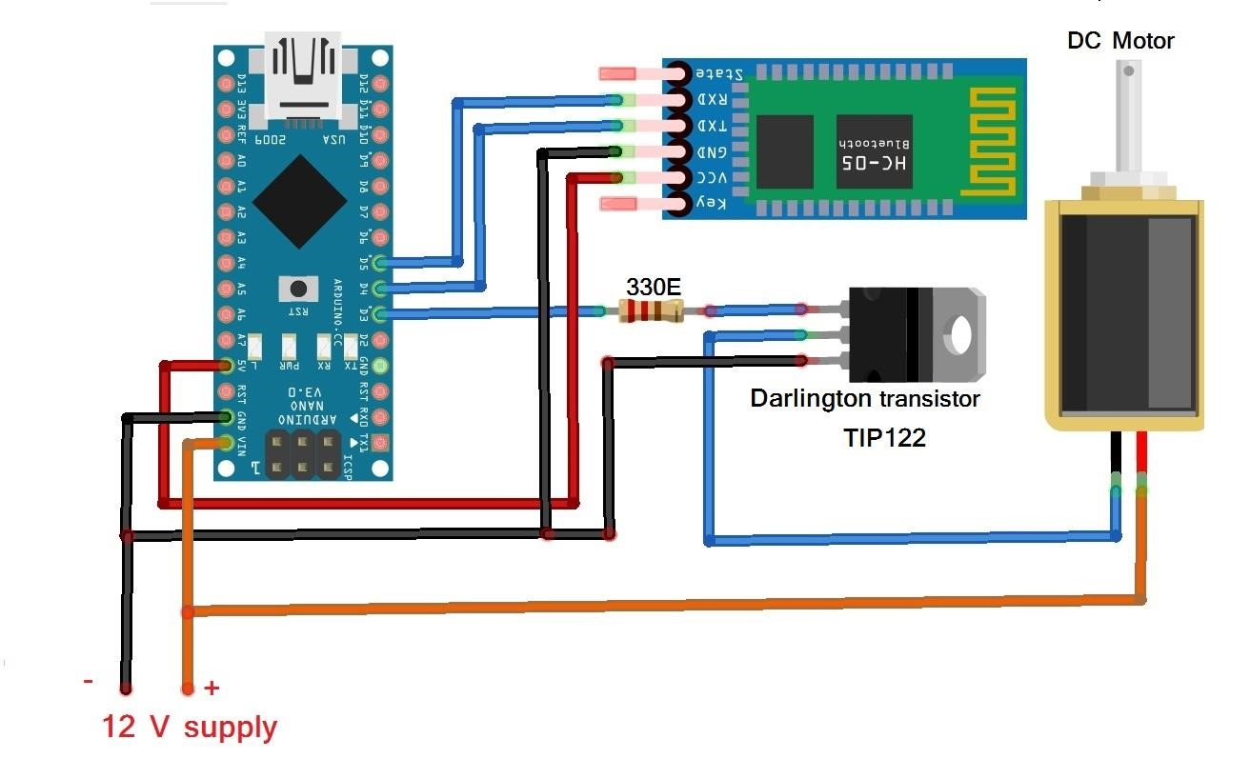

**BLOCK DIAGRAM:**

